**C:\Users\aktomar\Desktop\logo.png**

**Format No. QSP/7.1/01.F01 (B) Issue No.05 Rev. No 5 Dated: Jan 1, 2017**

**___________________________________________________________________________**

**UNIVERSITY OF PETROLEUM & ENERGY STUDIES**

**College of Engineering Studies**

**Dehradun**

**______________________________________________________**

**COURSE PLAN**

Programme : B.Tech (CS+ All IBM Branches)

Course : Data Communication and Networks Lab

Subject Code : CSEG 2109

No. of credits : 1

Semester : IV

Session : Jan 2020- May 2020

Batch : 2018-2022

Prepared by :

Email :

**Approved By**

_______________________ _______________________

Faculty HOD

UPES Campus Tel : +91-135-2770137

“Energy Acres” Fax : +91 135- 27760904

P.O. Bidholi, Via Prem Nagar Website : [www.upes.ac.in](http://www.upes.ac.in)

**COURSE PLAN**

1. **PREREQUISITE:**
   1. Basic Knowledge Mathematics.
   2. Basic Knowledge of Data structure
   3. Basic Knowledge of Algorithms

1. **PROGRAM OUTCOMES (POs) for DCN:**

**Program Outcomes for B. Tech. CSE After completion of the program the students will be able to:**

1. **Engineering knowledge**: Apply the knowledge of mathematics, science, engineering fundamentals, and an engineering specialization to the solution of complex engineering problems.
2. **Problem analysis**: Identify, formulate, review research literature, and analyze complex engineering problems reaching substantiated conclusions using first principles of mathematics, natural sciences, and engineering sciences.
3. **Design/development of solutions**: Design solutions for complex engineering problems and design system components or processes that meet the specified needs with appropriate consideration for the public health and safety, and the cultural, societal, and environmental considerations.
4. **Conduct investigations of complex problems**: Use research-based knowledge and research methods including design of experiments, analysis and interpretation of data, and synthesis of the information to provide valid conclusions.
5. **Modern tool usage**: Create, select, and apply appropriate techniques, resources, and modern engineering and IT tools including prediction and modeling to complex engineering activities with an understanding of the limitations.
6. **The engineer and society**: Apply reasoning informed by the contextual knowledge to assess societal, health, safety, legal and cultural issues and the consequent responsibilities relevant to the professional engineering practice.
7. **Environment and sustainability**: Understand the impact of the professional engineering solutions in societal and environmental contexts, and demonstrate the knowledge of, and need for sustainable development.
8. **Ethics**: Apply ethical principles and commit to professional ethics and responsibilities and norms of the engineering practice.
9. **Individual and team work**: Function effectively as an individual, and as a member or leader in diverse teams, and in multidisciplinary settings.
10. **Communication**: Communicate effectively on complex engineering activities with the engineering community and with society at large, such as, being able to comprehend and write effective reports and design documentation, make effective presentations, and give and receive clear instructions.
11. **Project management and finance**: Demonstrate knowledge and understanding of the engineering and management principles and apply these to one’s own work, as a member and leader in a team, to manage projects and in multidisciplinary environments.
12. **Life-long learning**: Recognize the need for, and have the preparation and ability to engage in independent and life-long learning in the broadest context of technological change.

**PROGRAM SPECIFIC OUTCOMES**

1. Perform system and application programming using computer system concepts, concepts of Data Structures, algorithm development, problem solving and optimizing techniques,
2. Apply software development and project management methodologies using concepts of front-end and back-end development and emerging technologies and platforms.
3. ------------------to be made for each vertical----------------------

.

1. **OBJECTIVES OF COURSE:-**

The objectives of this course are to:

1. Students should be able to classify the functions of layers in a network with fine- grained knowledge about classification of functionalities among network layers.
2. Student should be able to classify the network devices on the basis of their functionalities.
3. Student should be able to understand the real time networks including wired and wireless.
4. Students should be able to assess the pros of cons while selecting network devices in any network.
5. **COURSE OUTCOMES FOR Data Communication and Computer Networks: At the end of this course student should be able to**

CO1: Understand Theoretical Concepts of Network and Transmission Fundamentals.

CO2. Understand Evolution and Layered Architecture of Networks with detail information about the rationale behind each layer.

CO3. Understand the concept of Errors control and Multiplexing in the transmission Medium. Flow control and LAN protocols and LAN Standards.

CO4: Understanding the IP based networking and the concepts of Routing concepts and relation with Algorithm and Data Structures.

CO5: Understanding the Transport Layer and associated concepts of connection oriented and connection less behavior.

CO6: Understand the concepts of Application Layer concepts and protocols.

**Table: Correlation of POs v/s COs**

|  |  |  |  |  |  |  |  |  |  |  |  |
| --- | --- | --- | --- | --- | --- | --- | --- | --- | --- | --- | --- |
| PO/CO | PO1 | PO2 | PO3 | PO4 | PO5 | PO6 | PO7 | PO8 | PO9 | PO10 | PO11 |
| CO1 |  |  |  |  |  |  | 1 | 1 |  |  |  |
| CO2 |  |  |  |  |  |  |  |  | 2 | 2 |  |
| CO3 | 2 |  |  |  |  |  |  |  |  |  |  |
| CO4 |  |  |  |  |  |  | 2 |  |  |  |  |
| CO5 |  |  |  |  |  |  |  | 3 |  |  |  |
| CO6 |  |  |  |  |  |  |  | 1 |  |  |  |

WEAK 2. MODERATE 3. STRONG

**E. PEDAGOGY**

1. Viva Voce
2. Quiz
3. Lab Experiments

**F. COURSE COMPLETION PLAN**

|  |  |
| --- | --- |
| **Total Class room sessions** | 10 |
| **Total Quizzes** | 01 |
| **Total Viva Voce** | 02 |

One Session =120 minutes

1. **EVALUATION & GRADING**

Students will be evaluated based on the following 2 stages.

Viva Voce/Quiz - 50%

Performance & Records - 50%

**G1. VIVA VOCE /QUIZZES: (Weightage – 50%)** One quiz and two viva voce will be held during the semester. Those who do not appear in Viva-Voce and quiz examinations shall lose their marks.

**G2. Performance & Records: (Weightage – 50%)** Lab records will be checked on regular basis and students will also be evaluated in every lab session.

**G3. GRADING:**

The overall marks obtained at the end of the semester comprising all the above three mentioned shall be converted to a grade.

**COURSE PLAN**

|  |  |  |
| --- | --- | --- |
| **S.No** | **Lab Exercise** | **Contents** |
| **1.** | **Lab. Exercise 1** | **Familiarization of Network devices** |
| **2.** | **Lab. Exercise 2** | **Write a program for Bit stuffing and De-stuffing in a bit stream.** |
| **3.** | **Lab. Exercise 3** | **Write a program for CRC and Hamming code.** |
| **4.** | **Lab. Exercise 4** | **Familiarization of Network IP & Sub netting & super netting** |
| **5.** | **Lab. Exercise 5** | **Familiarization of Basic network command and Network configuration commands** |
| **6.** | **Lab. Exercise  6** | **Set –up the network topology using two routers on Packet tracer** |
| **7.** | **Lab. Exercise  7** | **Set –up the network topology using more than two routers on Packet tracer** |
| **8.** | **Lab. Exercise  8** | **Distance Vector Routing protocol** |
| **9.** | **Lab. Exercise  9** | **Link State Vector Routing protocol** |
| **10.** | **Lab. Exercise  10** | **Border gateway protocol** |

**Note\***

**The problems will be solved using any Programming Language (experiments 2 & 3), Packet Tracer software or GNS3 (experiments 4-10). Proper lab records of all the experiments will be maintained by the students, in practical file as well as in their directory.**

**Experiment- 1**

**Familiarization of Network devices**

**Aim:** Study of the following Network devices in detail:

* Repeater
* Hub
* Switch
* Bridge
* Router
* Gate way

**Apparatus (Software):** No Software or hardware needed.

**Theory:** In Data communication & network, network devices play an important role. Each network devices are considered as node of a graph. Network devices are components used to connect computers or other electronic devices together so that they can share files or resources like printers or fax machines. Devices used to setup a Local Area Network (LAN) are the most common types of network devices used by the public. A LAN requires a hub, router, switch, Bridge, cabling or radio technology, network cards, and if online access is desired, a high-speed modem. This is much less complicated than it might sound to someone new to networking.

**Procedure:** Explain each Network devices in details with proper diagram. Write short notes on each Network devices.

**Conclusion:** Gain the knowledge about the Network Devices.

**Experiment- 2**

**Write a program for Bit stuffing and De-stuffing in a bit stream.**

**Aim:** Study & implementation of the concept of Bit Stuffing and De-Stuffing.

**Apparatus (Software):** Any programming language.

**Theory:** Data link layer is responsible for something called Framing, which is the division of stream of bits from network layer into manageable units (called frames). Frames could be of fixed size or variable size. In variable-size framing, we need a way to define the end of the frame and the beginning of the next frame.

**Bit stuffing** is the insertion of non-information bits into data. Note that stuffed bits should not be confused with overhead bits. **Overhead bits** are non-data bits that are necessary for transmission (usually as part of headers, checksums etc.).

**Bit De-stuffing** is the deletion of non-information bits from the data.

**Procedure:** Understand the concept of Bit stuffing & De-stuffing and write the program.

**Conclusion:** Gain the knowledge about the bit stuffing and de-stuffing.

**Experiment- 3**

**Write a program for CRC and Hamming code.**

**Aim:** Study & implementation of the concept of CRC and Hamming code.

**Apparatus (Software):** Any programming language.

**Theory:** A cyclic redundancy check **(CRC)** is an error-detecting code commonly used in digital networks and storage devices to detect accidental changes to raw data.

**Hamming code** is a set of error-correction codes that can be used to detect and correct the errors that can occur when the data is moved or stored from the sender to the receiver.

**Procedure:** Understand the concept of CRC and Hamming code and write the program.

**Conclusion:** Gain the knowledge about the CRC and Hamming code.

**EXPERIMENT-4**

**Familiarization of Network IP & Subnetting & Supernetting**

**Aim:** Study of Network IP and Sub Netting & Super Netting.

* Classification of IP address

**Apparatus (Software):** No Software or hardware needed.

**Theory:** An Internet Protocol address (IP address) is a numerical label assigned to each device (e.g., computer, printer) participating in a computer network that uses the Internet Protocol for communication. An IP address serves two principal functions: host or network interface identification and location addressing. Its role has been characterized as follows: "A name indicates what we seek. An address indicates where it is. A route indicates how to get there."

A sub network, or subnet, is a logically visible subdivision of an IP network. The practice of dividing a network into two or more networks is called sub netting. A super network, or super net, is an Internet Protocol (IP) network that is formed from the combination of two or more networks (or subnets) with a common Classless Inter-Domain Routing (CIDR) prefix. The new routing prefix for the combined network aggregates the prefixes of the constituent networks. It must not contain other prefixes of networks that do not lie in the same routing path. The process of forming a super net is often called super netting, prefix aggregation, route aggregation, or route summarization.

**Procedure:** Following is required to be study under this practical.

* Classification of IP address
* Sub netting

Why we Develop sub netting and How to calculate subnet mask and how to identify subnet address.

* Super netting

Why we develop super netting and How to calculate super net mask and how to identify super net address.

**Conclusion:** Gain the knowledge about the IP address and Sub netting & Super netting.

**EXPERIMENT-5**

**Familiarization of Basic network command and Network configuration commands**

**Aim:** Study of basic network command and Network configuration commands.

**Apparatus (Software):** Command Prompt And Packet Tracer or GNS3.

**Theory:** Cisco Packet Tracer is a network simulation program that allows students to experiment with network behavior and ask “what if” questions. As an integral part of the Networking Academy comprehensive learning experience, Packet Tracer provides simulation, visualization, authoring, assessment, and collaboration capabilities and facilitates the teaching and learning of complex technology concepts.

**Procedure:** To do this EXPERIMENT- follows these steps:

In this EXPERIMENT- students have to understand basic networking commands e.g ping, traceroute etc.

All commands related to Network configuration which includes how to switch to privilege mode and normal mode and how to configure router interface and how to save this configuration to flash memory or permanent memory. There are other modes than these. Not all commands work in all modes. Be careful, If you type in a command that you know is correct—show running-config, for example—and you get an error, make sure that you are in the correct mode.

This commands includes

* Configuring the Router commands
* General Commands to configure network
* Privileged Mode commands of a router
* Router Processes & Statistics
* IP Commands
* Other IP Commands e.g. show ip route etc.

**Note:** When you are entering a command, you can use the tab key to complete the command. Enter the first few characters of a command and press the tab key. If the characters are unique to the command, the rest of the command is entered in for you. This is helpful if you are unsure about the spelling of a command. For example, if we write in enable mode, “sh” and press tab button, “show” command will be written on the CLI mode.

**Conclusion:** Gain the knowledge about the network commands and network configure commands.

**EXPERIMENT-6**

**Set –up the network topology using two Routers**

**Aim:** Configure a Network topology using two router on packet tracer software.

**Apparatus (Software):** Packet tracer Software

**Theory:** Network Topology refers to layout of a network and how different nodes in a network are connected to each other and how they communicate. A router is a device that forwards data packets between computer networks, creating an overlay internetwork. A router is connected to two or more data lines from different networks. When a data packet comes in one of the lines, the router reads the address information in the packet to determine its ultimate destination. Then, using information in its routing table or routing policy, it directs the packet to the next network on its journey. Routers perform the "traffic directing" functions on the Internet. A data packet is typically forwarded from one router to another through the networks that constitute the internetwork until it reaches its destination node.

**Procedure:** To implement this practical following network topology is required to be configured using the commands learned in previous practical.

After configuring the given network a packet should be ping from any one machine to another

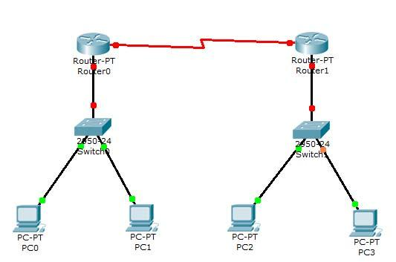

**Conclusion:** Successfully network topology is configured using two routers on Packet tracer.

**EXPERIMENT-7**

**Set –up the network topology using more than two routers**

**Aim:** Configure a Network topology using more than two routers on packet tracer software.

**Apparatus (Software):** Packet tracer Software

**Theory:** 'Network topology is an arrangement of the various elements (links, nodes, etc.) of a computer network. Essentially, it is the topological structure of a network, and may be depicted physically or logically. Physical topology refers to the placement of the network's various components, including device location and cable installation, while logical topology shows how data flows within a network, regardless of its physical design. Distances between nodes, physical interconnections, transmission rates, and/or signal types may differ between two networks, yet their topologies may be identical.

**Procedure:** To implement this practical following network topology is required to be configured using the commands learned in previous practical.

After configuring the given network a packet should be ping from any one machine to another.

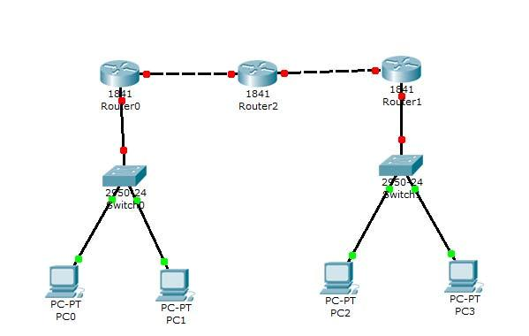

**Conclusion:** Successfully network topology is configured using Packet tracer.

**EXPERIMENT-8**

**Distance Vector Routing protocol**

**Aim:** Configure a Network using Distance Vector Routing protocol.

* RIP

**Apparatus (Software):** packet tracer software

**Theory:** In computer communication theory relating to packet-switched networks, a distance-vector routing protocol is one of the two major classes of routing protocols, the other major class being the link-state protocol. Distance-vector routing protocols use the Bellman–Ford algorithm, Ford–Fulkerson algorithm, or DUAL FSM (in the case of Cisco Systems’s protocols) to calculate paths. A distance-vector routing protocol requires that a router informs its neighbors of topology changes periodically. Compared to link-state protocols, which require a router to inform all the nodes in a network of topology changes, distance-vector routing protocols have less computational complexity and [message overhead](http://en.wikipedia.org/w/index.php?title=Message_overhead&action=edit&redlink=1).

The Routing Information Protocol (RIP) is one of the oldest distance-vector routing protocols, which employs the hop count as a routing metric. RIP prevents routing loops by implementing a limit on the number of hops allowed in a path from the source to a destination. The maximum number of hops allowed for RIP is 15. This hop limit, however, also limits the size of networks that RIP can support. A hop count of 16 is considered an infinite distance, in other words the route is considered unreachable.

**Procedure:**

1. Develop a Topology shown in figure given below.

1. Configure all Routers
2. Implement RIP protocols in Router to configure Network.

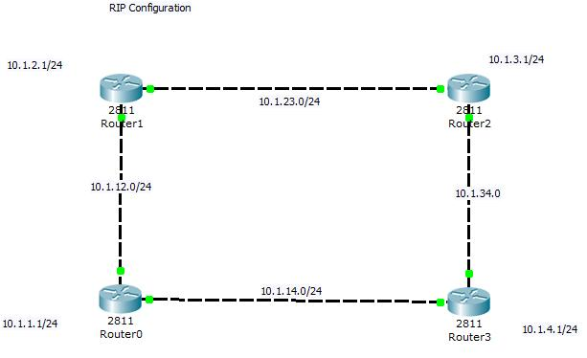

**Conclusion:** Successfully configured the Distance vector routing protocol

**EXPERIMENT-9**

**Link State Vector Routing protocol**

**Aim:** Configure Network using Link State Vector Routing protocol.

* OSPF

**Apparatus (Software):** Packet Tracer Software/GNS3

**Theory:** Open Shortest Path First (OSPF) is a link-state routing protocol for Internet Protocol (IP) networks. It uses a link state routing algorithm and falls into the group of interior routing protocols, operating within a single autonomous system (AS). It is defined as OSPF Version 2 in RFC 2328 (1998) for IPv4. The updates for IPv6 are specified as OSPF Version 3 in RFC 5340(2008).

OSPF is perhaps the most widely used interior gateway protocol (IGP) in large enterprise networks. IS-IS, another link-state dynamic routing protocol, is more common in large service provider networks. The most widely used exterior gateway protocol is the Border Gateway Protocol (BGP), the principal routing protocol between autonomous systems on the Internet.

**Procedure:**

* Develop a Topology shown in figure given below.
* Configure all the workstations
* Configure all switches
* Configure all Routers
* Implement OSPF protocols in Router to configure Network.

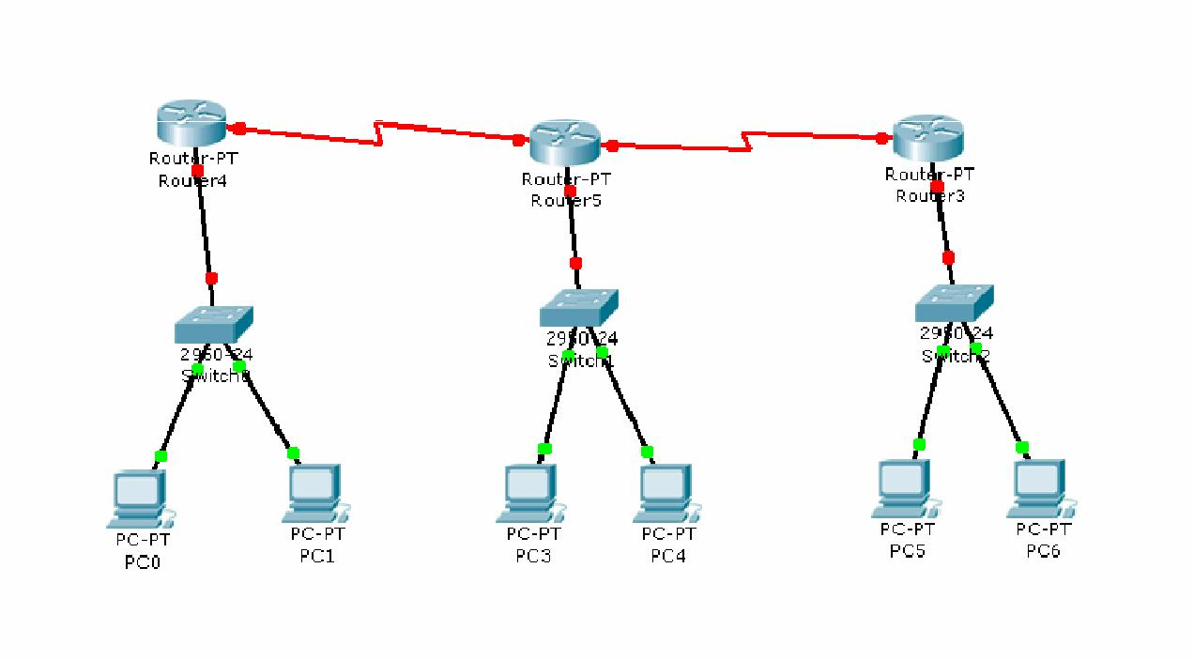

**Conclusion:** Successfully configured the Distance vector routing protocol.

**EXPERIMENT-10**

**Border gateway protocol**

**Aim:** Configure Network using Border gateway protocol.

**Apparatus (Software):** Packet Tracer Software/GNS3

**Theory:** Border Gateway Protocol (BGP) is a standardized exterior gateway protocol designed to exchange routing and reachability information between autonomous systems (AS) on the Internet. The protocol is often classified as a path vector protocol, but is sometimes also classed as a distance vector routing protocol. The Border Gateway Protocol does not use Interior Gateway Protocol (IGP) metrics, but makes routing decisions based on paths, network policies and/or rule-sets configured by a network administrator. The Border Gateway Protocol plays a key role in the overall operation of the Internet and is involved in making core routing decisions.

**Procedure:**

* Develop a Topology shown in figure given below.
* Configure all the workstations
* Configure all switches
* Configure all Routers
* Implement BGP protocols in Router to configure Network.

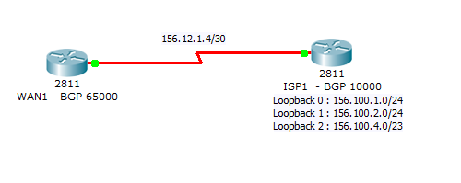

**Conclusion:** Successfully configured the Border gateway protocol.

**Sample format for Indirect Assessment of Course outcomes**

|  |
| --- |
| NAME: |
| ENROLLMENT NO: |
| SAP ID: |
| COURSE: |
| PROGRAM: |

Please rate the following aspects of course outcomes of Data Communication and Computer Networks.

Use the scale 1-4*

|  |  |  |  |  |  |
| --- | --- | --- | --- | --- | --- |
| Sl. No. |  | 1 | 2 | 3 | 4 |
| 1 | CO1: Understand Theoretical Concepts of Network and Transmission Fundamentals. |  |  |  |  |
| 2 | CO2. Understand Evolution and Layered Architecture of Networks with detail information about the rationale behind each layer. |  |  |  |  |
| 3 | CO3. Understand the concept of Errors control and Multiplexing in the transmission Medium. Flow control and LAN protocols and LAN Standards. |  |  |  |  |
| 4 | CO4: Understanding the IP based networking and the concepts of Routing concepts and relation with Algorithm and Data Structures. |  |  |  |  |
| 5 | CO5: Understanding the Transport Layer and associated concepts of connection oriented and connection less behavior. |  |  |  |  |
| 6 | CO6: Understand the concepts of Application Layer concepts and protocols. |  |  |  |  |

3

Below Average

Good

1

**\***

Very Good

Average

4

2